AQ1:
#include <stdio.h>
#include <stdlib.h>

#define MAX 100

struct Node {
int vertex;
struct Node* next;
};

struct Node* adjList[MAX];
int visited[MAX];

int queue[MAX], front = -1, rear = -1;

void enqueue(int value) {
if (rear == MAX - 1)
return;
if (front == -1) front = 0;
queue[++rear] = value;
}

int dequeue() {
if (front == -1)
return -1;
int value = queue[front++];
if (front > rear) front = rear = -1;
return value;
}

void addEdge(int src, int dest) {
struct Node* newNode = (struct Node*)malloc(sizeof(struct Node));
newNode->vertex = dest;
newNode->next = adjList[src];
adjList[src] = newNode;

newNode = (struct Node*)malloc(sizeof(struct Node));
newNode->vertex = src;
newNode->next = adjList[dest];
adjList[dest] = newNode;
}

void BFS(int start, int n) {
for (int i = 0; i < n; i++)
visited[i] = 0;

enqueue(start);
visited[start] = 1;

printf("BFS Traversal: ");
while (front != -1) {
int v = dequeue();
printf("%d ", v);

struct Node* temp = adjList[v];
while (temp != NULL) {
if (!visited[temp->vertex]) {
enqueue(temp->vertex);
visited[temp->vertex] = 1;
}
temp = temp->next;
}
}
printf("\n");
}

int main() {
int n, edges;
int src, dest, start;

printf("Enter number of vertices: ");
scanf("%d", &n);

for (int i = 0; i < n; i++)
adjList[i] = NULL;

printf("Enter number of edges: ");
scanf("%d", &edges);

printf("Enter edges (u v):\n");
for (int i = 0; i < edges; i++) {
scanf("%d %d", &src, &dest);
addEdge(src, dest);
}

printf("Enter starting vertex for BFS: ");
scanf("%d", &start);

BFS(start, n);

return 0;
}

Output:
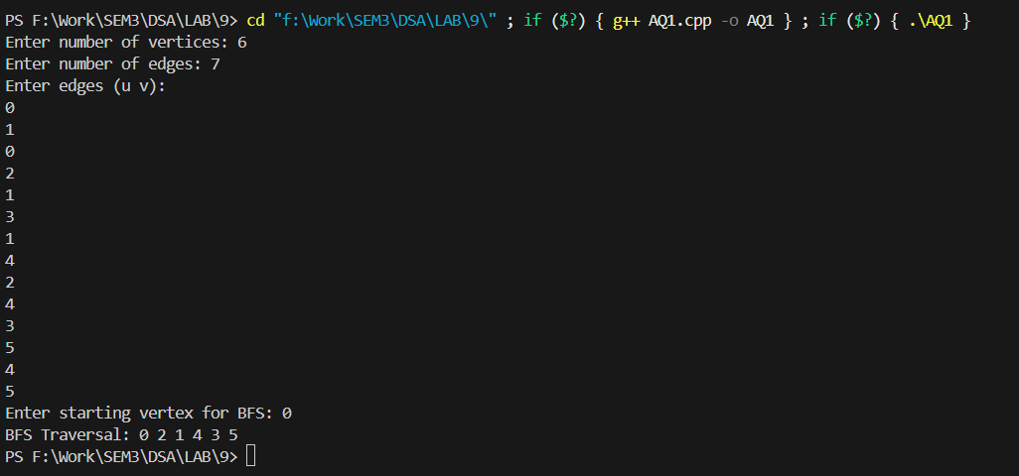
AQ2:
#include <stdio.h>
#include <stdlib.h>

#define MAX 100

struct Node {
int vertex;
struct Node* next;
};

struct Node* adjList[MAX];
int visited[MAX];

void addEdge(int src, int dest) {
struct Node* newNode = (struct Node*) malloc(sizeof(struct Node));
newNode->vertex = dest;
newNode->next = adjList[src];
adjList[src] = newNode;

newNode = (struct Node*) malloc(sizeof(struct Node));
newNode->vertex = src;
newNode->next = adjList[dest];
adjList[dest] = newNode;
}

void DFS(int v) {
visited[v] = 1;
printf("%d ", v);

struct Node* temp = adjList[v];
while (temp != NULL) {
if (!visited[temp->vertex]) {
DFS(temp->vertex);
}
temp = temp->next;
}
}

int main() {
int n, edges;
int src, dest, start;

printf("Enter number of vertices: ");
scanf("%d", &n);

for (int i = 0; i < n; i++)
adjList[i] = NULL;

printf("Enter number of edges: ");
scanf("%d", &edges);

printf("Enter edges (u v):\n");
for (int i = 0; i < edges; i++) {
scanf("%d %d", &src, &dest);
addEdge(src, dest);
}

for (int i = 0; i < n; i++)
visited[i] = 0;

printf("Enter starting vertex for DFS: ");
scanf("%d", &start);

printf("DFS Traversal: ");
DFS(start);
printf("\n");

return 0;
}

Output:
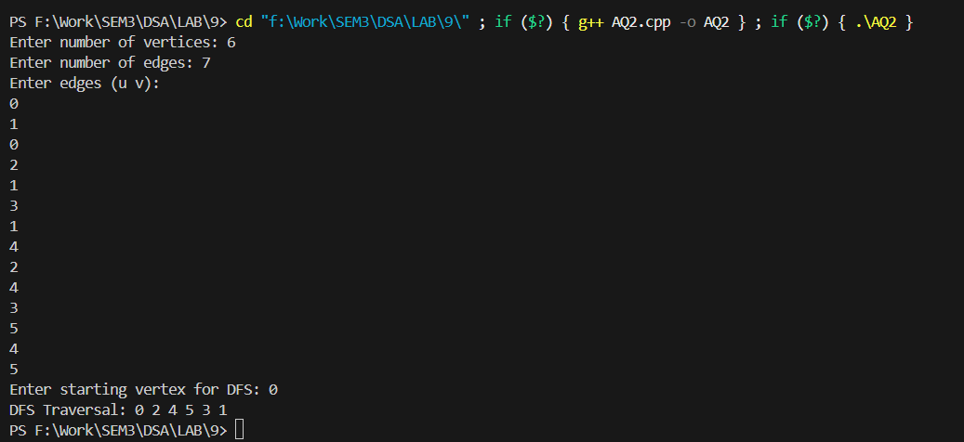
AQ3:
#include <bits/stdc++.h>
using namespace std;

struct Edge {
int u, v, w;
bool operator<(const Edge& other) const {
return w < other.w;
}
};

vector<int> parent, rankSet;
int findSet(int x) {
if (parent[x] != x)
parent[x] = findSet(parent[x]);
return parent[x];
}
void unionSet(int x, int y) {
x = findSet(x);
y = findSet(y);
if (x != y) {
if (rankSet[x] < rankSet[y]) swap(x, y);
parent[y] = x;
if (rankSet[x] == rankSet[y]) rankSet[x]++;
}
}

int KruskalMST(int V, vector<Edge>& edges) {
sort(edges.begin(), edges.end());
parent.resize(V);
rankSet.assign(V, 0);
for (int i = 0; i < V; i++) parent[i] = i;

int mstWeight = 0;
cout << "\nEdges in Kruskal MST:\n";

for (auto &e : edges) {
if (findSet(e.u) != findSet(e.v)) {
unionSet(e.u, e.v);
mstWeight += e.w;
cout << e.u << " - " << e.v << " = " << e.w << "\n";
}
}
return mstWeight;
}

int PrimMST(int V, vector<vector<pair<int,int>>>& adj) {
vector<int> key(V, INT_MAX), parent(V, -1);
vector<bool> inMST(V, false);
key[0] = 0;

priority_queue<pair<int,int>, vector<pair<int,int>>, greater<pair<int,int>>> pq;
pq.push({0, 0});

while (!pq.empty()) {
int u = pq.top().second;
pq.pop();
inMST[u] = true;

for (auto &p : adj[u]) {
int v = p.first, weight = p.second;
if (!inMST[v] && weight < key[v]) {
parent[v] = u;
key[v] = weight;
pq.push({key[v], v});
}
}
}

int mstWeight = 0;
cout << "\nEdges in Prim MST:\n";
for (int i = 1; i < V; i++) {
cout << parent[i] << " - " << i << " = " << key[i] << "\n";
mstWeight += key[i];
}
return mstWeight;
}

int main() {
int V, E;
cout << "Enter number of vertices and edges: ";
cin >> V >> E;

vector<Edge> edges;
vector<vector<pair<int,int>>> adj(V);

cout << "Enter edges (u v weight):\n";
for (int i = 0; i < E; i++) {
int u, v, w;
cin >> u >> v >> w;
edges.push_back({u, v, w});
adj[u].push_back({v, w});
adj[v].push_back({u, w});
}

int kruskalWeight = KruskalMST(V, edges);
cout << "\nTotal weight of Kruskal MST = " << kruskalWeight << endl;

int primWeight = PrimMST(V, adj);
cout << "\nTotal weight of Prim MST = " << primWeight << endl;

return 0;
}
Output:
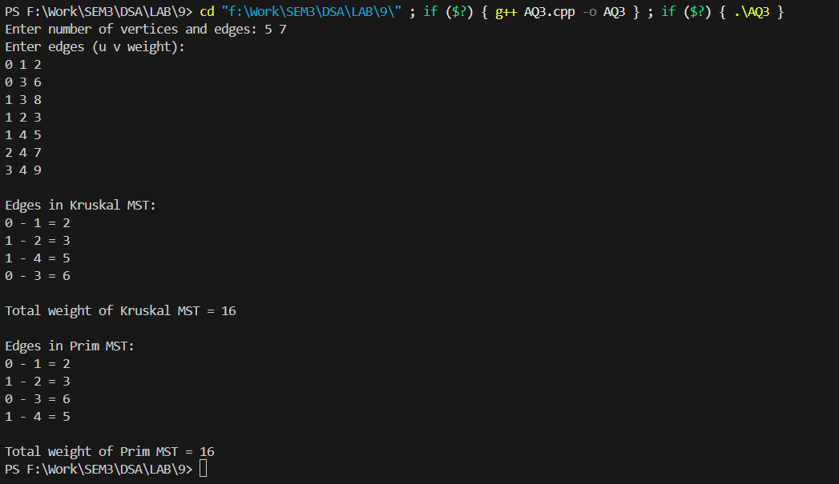

AQ4:
#include <stdio.h>
#define INF 999999

void dijkstra(int n, int graph[10][10], int src) {
int dist[10], visited[10];
int i, j, count, minDist, nextNode;

// Initialize distances & visited array
for (i = 0; i < n; i++) {
dist[i] = graph[src][i];
visited[i] = 0;
}

dist[src] = 0; // Distance to source = 0
visited[src] = 1; // Mark source visited
count = 1;

// Find shortest paths for all nodes
while (count < n) {
minDist = INF;

// Pick the nearest unvisited vertex
for (i = 0; i < n; i++) {
if (!visited[i] && dist[i] < minDist) {
minDist = dist[i];
nextNode = i;
}
}

visited[nextNode] = 1;

// Update distances of adjacent vertices
for (i = 0; i < n; i++) {
if (!visited[i]) {
if (minDist + graph[nextNode][i] < dist[i]) {
dist[i] = minDist + graph[nextNode][i];
}
}
}
count++;
}

// Print shortest distances
printf("\nShortest distances from source node %d:\n", src);
for (i = 0; i < n; i++) {
printf("To node %d = %d\n", i, dist[i]);
}
}

int main() {
int n, graph[10][10], src;
printf("Enter number of vertices: ");
scanf("%d", &n);

printf("\nEnter adjacency matrix (enter %d for INF if no edge):\n", INF);
for (int i = 0; i < n; i++) {
for (int j = 0; j < n; j++) {
scanf("%d", &graph[i][j]);
}
}

printf("\nEnter source vertex: ");
scanf("%d", &src);

dijkstra(n, graph, src);
return 0;
}
Output:
